**Digital Marketing System for Jombang's Cultural Diversity and Tourism Based on a Website**

Siti Sufaidah1, Rizky Dwi Saputra2, Achmad Agus Athok Miftachuddin3

1,2,3 Information Systems, Universitas KH. A. Wahab Hasbullah

Email: [rdwisa0102@gmail.com](mailto:rdwisa0102@gmail.com)

ABSTRACT

Jombang Regency, East Java, has significant potential in the tourism and cultural sectors; however, the promotion and marketing of tourist destinations in this area remain limited. This Final Project report discusses the development of a website-based digital marketing system designed to enhance exposure and access to information about various tourist and cultural destinations in Jombang Regency. The system is equipped with features such as comments, ratings, and location maps, which facilitate users in discovering and exploring the available destinations. The objective of this research is to implement an effective digital marketing strategy to increase the number of tourists visiting Jombang Regency. The system, developed using PHP and MySQL, provides accurate and engaging information about natural, religious, popular, and historical tourist destinations in Jombang. The research findings indicate that the implementation of this system can enhance the visibility of tourist destinations in Jombang and significantly contribute to local economic growth. Through integrated and sustainable digital marketing, it is hoped that Jombang Regency can become one of Indonesia's leading tourist destinations, widely recognized both nationally and internationally.

**Keywords**: digital marketing, tourism, culture, website, Jombang.

INTRODUCTION

Jombang Regency in East Java is rich in tourism and cultural potential, with attractions such as Goa Gong, Tretes Waterfall, Gus Dur’s Tomb, and Sumber Boto Hot Springs. However, tourism promotion in Jombang remains limited, with scattered and unstructured information making it difficult for tourists to discover these destinations.

To address this issue, a website-based digital marketing strategy is proposed. The official website will serve as an information hub, providing engaging content on tourist destinations, cultural events, local cuisine, and accommodations in Jombang. It will also include interactive features such as comments, ratings, and maps to enhance user experience and provide valuable feedback to destination managers.

Social media will complement the website by increasing visibility and engagement with potential tourists. Collaboration with local governments, businesses, communities, and the media is also crucial to boost exposure. Additionally, improving infrastructure and service quality is necessary to attract more visitors.

This integrated strategy aims to increase awareness of Jombang's tourism and culture, contributing to local economic growth and the well-being of the community.

METHOD

1. Research Methods

This research employs the System Development Method to develop a Website-Based Digital Marketing System for Cultural and Tourism Diversity in Jombang (User). This method is characterized by its linear approach, where each phase—from planning to implementation—is conducted sequentially. This ensures that every aspect of the system development is thoroughly analyzed before moving to the next phase. The outcome is expected to facilitate users in finding information about Jombang's natural, religious, popular, and historical tourism, providing a comprehensive guide. Users can also leave comments and ratings on the destinations they visit and view the locations of tourism and cultural sites. These features aim to enhance user interaction and provide valuable feedback for destination managers to improve service quality.

1. System Design

According to Sukamto & Shalahuddin (2018:155), use case or use case diagrams are modeling tools for the behavior of the information system being developed.(Muhamad Tabrani, Suhardi, 2021)

A Use Case Diagram is a visual representation that shows how a system interacts with the users involved. This diagram is used to understand how users will interact with the system.

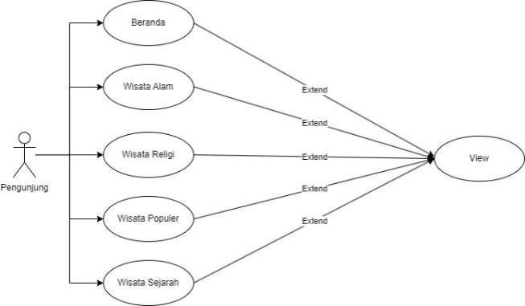

Figure 1. Use Case Diagram

The use case diagram above illustrates the interaction between users and various features within the Website-Based Digital Marketing System for Jombang's Cultural and Tourism Diversity. Users can access features such as Home, Nature Tourism, Religious Tourism, Popular Tourism, and Historical Tourism. This diagram also helps to better understand how the system is used to view various information on the website.

RESULT AND DISCUSSION

1. **System**

According to (Andrianof, 2018), a system is a combination of several elements, components, or variables that are integrated to form a cohesive whole, aiming to achieve a specific goal and objectives.. (Maydianto & Ridho, 2021)

In other words, a system is an organized structure where its elements work synergistically to achieve the desired final outcome. This approach emphasizes the importance of cohesion and cooperation among components in realizing a shared goal.

1. **Digital Marketing**

Digital marketing is a term that refers to the marketing of goods or services that is targeted, measurable, and interactive, utilizing digital technologies. The primary goals of digital marketing are to promote brands, shape preferences, and increase sales traffic through various digital marketing techniques. Digital marketing is also known as online marketing or internet marketing. Although it shares similarities with conventional marketing, it is distinguished by the tools used. (Prasetyowati et al., 2020)

1. **UML (Unified Modeling Language)**

According to (Booch, 2005), UML (Unified Modeling Language) is a language. A language consists of words and has rules for combining these words to create communication. A modeling language is one where the words and their rules focus on depicting a system both conceptually and physically. A modeling language like UML has become the standard language for planning an application.(Hadi Zakaria, 2019)

1. **Website**

According to Ramanda (2017), a website is one of the rapidly growing resources on the Internet. Information on a website is distributed through hypertext, which allows short text to refer to other documents. According to Fridayanthie & Mahdiati (2016), a website is essentially an abbreviation for the World Wide Web (WWW). Information on the WWW is stored on web servers so that it can be accessed through browsers such as Internet Explorer or Mozilla Firefox.(Eka Wida Fridayanthie, 2016)

**Result**

According to Rosa and Shalahuddin (2014:275-276), Black-box testing is a software testing method that focuses on evaluating the functional specifications of the software without examining the design and code of the program.(Eka Wida Fridayanthie, 2016)

This system was tested using the Black Box method. This method tests each component of the digital marketing website for Jombang's cultural and tourism diversity. The purpose of Black Box testing is to identify any functions that may not be working as expected or if any features are not functioning.

* Home Page Testing 1

Table 1. Home Page Testing 1

|  |  |
| --- | --- |
| **Data Cases and Test Results** | |
| Action | Tourists visit the Jombang tourism website via the available link. |
| Expected Outcome | Upon successfully accessing the link, visitors are immediately directed to the home page, which displays the main information and features such as Home, Nature, Religious, Popular, and History. |
| Result | Successfully accessed the home page, and the main information and features like Home, Nature, Religious, Popular, and History were displayed. |
| Conclusion | Successful |

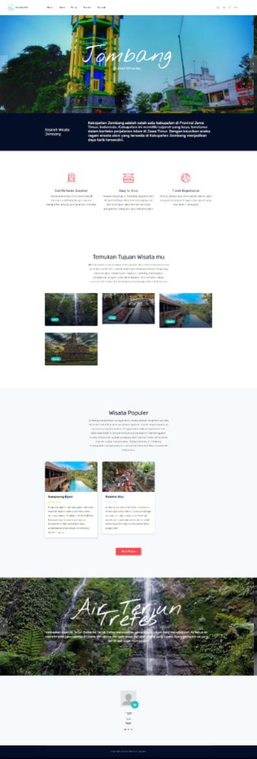

Figure 2. Home Page 1

* Home Page Testing 2

Table 2. Home Page Testing 2

|  |  |
| --- | --- |
| **Data Cases and Test Results** | |
| Action | Scroll down from the home page 1. |
| Expected Outcome | Display several popular tourist attractions in Jombang Regency, followed by a snapshot of various tourist comments about the visited destinations. There should also be a slider showcasing several attractions along with brief descriptions. |
| Result | Successfully displayed several popular attractions, the description slider of several attractions, and the comments uploaded to the website about the various attractions. |
| Conclusion | Successful |

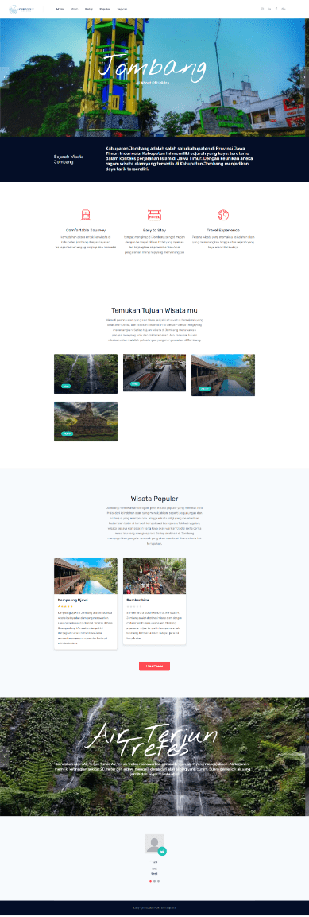

Figure 3. Home Page 2

* Testing Nature Tourism Page

Table 3. Testing Nature Tourisme Page

|  |  |
| --- | --- |
| **Data Cases and Test Results** | |
| Action | Click on the "Nature Tourism" feature |
| Expected Outcome | Visitors are directed to the nature tourism page, which displays a list of natural attractions in Jombang Regency. |
| Result | Visitors were directed to the nature tourism page, where a list and images of natural attractions in Jombang Regency were displayed. |
| Conclusion | Successful |

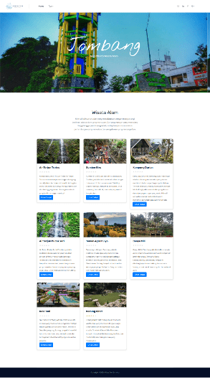

Figure 4. Nature Tourisme Page

* Detailed testing of the Nature Tourism Page

Table 4. Detailed testing of the Nature Tourism Page

|  |  |
| --- | --- |
| **Data Cases and Test Results** | |
| Action | Click on the details of one of the nature tourism attractions. |
| Expected Outcome | Display the details of the nature tourism attraction, including a description of the attraction, a form for submitting comments and ratings, a map showing the location of the attraction, and the comments previously uploaded by visitors. |
| Result | Displayed the details of the nature attraction, including a description, a form for submitting comments and ratings, a map showing the location, and the comments previously uploaded by visitors. |
| Conclusion | Successful |

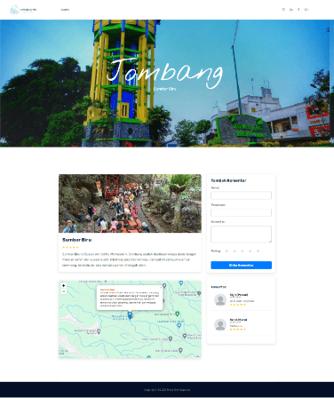

Figure 5. Detailed of the Nature Tourism Page

* Testing Wisata Religi Pages

Table 5. Wisata Religi Pages

|  |  |
| --- | --- |
| **Data Cases and Test Results** | |
| Action | Click on the religious tourism feature. |
| Expected Outcome | The visitor is directed to the religious tourism page, displaying a list of religious tourism sites in Jombang Regency. |
| Result | The visitor successfully accessed the religious tourism page, which displayed a list and images of religious tourism sites in Jombang Regency. |
| Conclusion | Successful |

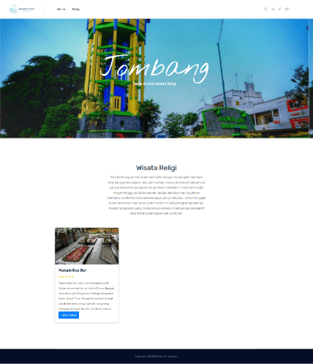

Figure 6. Wisata Religi Pages

* Testing Religious Tourism Detail Pages

Table 6. Religious Tourism Detail Pages

|  |  |
| --- | --- |
| **Data Cases and Test Results** | |
| Action | Click on the details of a religious tourism site. |
| Expected Outcome | The visitor is directed to the detail page of the selected religious tourism site, displaying details such as a description of the site, comments from previous visitors, and a map showing the location of the popular tourist site. |
| Result | Successfully accessed the detail page of the selected religious tourism site, which displayed the site’s description, comments from previous visitors, and a map showing the location of the popular tourist site. |
| Conclusion | Successful |

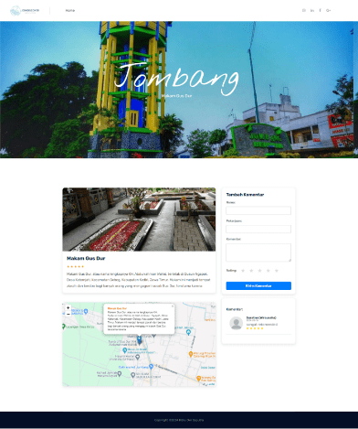

Figure 7. Religious Tourism Detail Pages

* Testing Popular Tourism Pages

Table 7. Popular Tourism Pages

|  |  |
| --- | --- |
| **Data Cases and Test Results** | |
| Action | Click on the popular tourism feature |
| Expected Outcome | The visitor is directed to the popular tourism page, displaying a list of popular tourist sites in Jombang Regency. |
| Result | The visitor successfully accessed the popular tourism page, which displayed a list and images of popular tourist sites in Jombang Regency. |
| Conclusion | Successful |

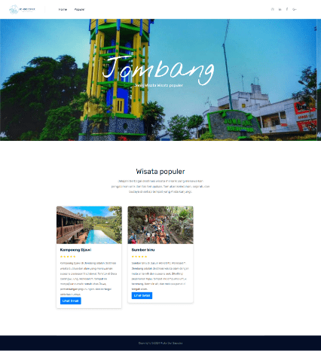

Figure 8. Popular Tourism Pages

* Testing popular Tourism Detail Pages

Table 8. popular Tourism Detail Pages

|  |  |
| --- | --- |
| **Data Cases and Test Results** | |
| Action | Click on the details of a religious tourism site. |
| Expected Outcome | The visitor is directed to the detail page of the selected religious tourism site, displaying details such as a description of the site, comments from previous visitors, and a map showing the location of the popular tourist site. |
| Result | Successfully accessed the detail page of the selected religious tourism site, which displayed the site’s description, comments from previous visitors, and a map showing the location of the popular tourist site. |
| Conclusion | Successful |

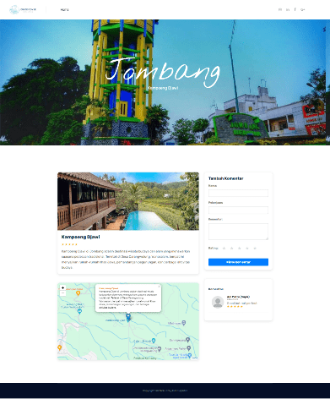

Figure 9. popular Tourism Detail Pages

* Testing the Historical Tourism Page

Table 9. Historical Tourism Page

|  |  |
| --- | --- |
| **Data Cases and Test Results** | |
| Action | Click on the historical tourism feature. |
| Expected Outcome | The visitor is directed to the historical tourism page, displaying a list of historical tourist sites in Jombang Regency. |
| Result | The visitor successfully accessed the historical tourism page, which displayed a list and images of historical tourist sites in Jombang Regency. |
| Conclusion | Successful |

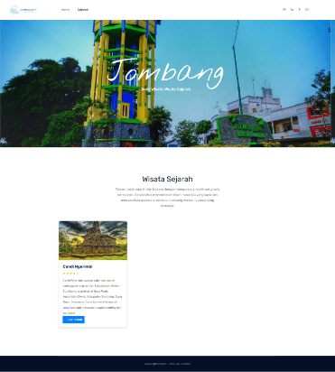

Figure 10. Historical Tourism Page

* Testing the Historical Tour Detail Page

Table 10. Historical Tour Detail Page

|  |  |
| --- | --- |
| **Data Cases and Test Results** | |
| Action | Click on the details of a historical tourism site. |
| Expected Outcome | The visitor is directed to the detail page of the selected historical tourism site, displaying details such as a description of the site, comments from previous visitors, and a map showing the location of the popular tourist site. |
| Result | Successfully accessed the detail page of the selected historical tourism site, which displayed a description of the site, comments from previous visitors, and a map showing the location of the popular tourist site. |
| Conclusion | Successful |

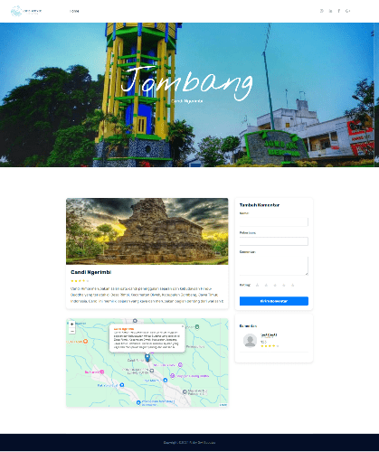

Figure 11. Historical Tour Detail Page

**Discussion**

Usability testing was conducted to determine whether the designed system can be easily used by users, how efficiently and effectively the system can help users achieve their goals, and whether users are satisfied with the system. The results of this testing are evaluated using the following categories.

* VS : Very Satisfied
* S : Satisfied
* N : Neutral
* D : Dissatisfied
* SD : Strongly Dissatisfied

Table 11. Usability Testing

|  |  |  |  |  |  |  |
| --- | --- | --- | --- | --- | --- | --- |
| No. | Pertanyaan | VS | S | N | D | SD |
| 1. | How satisfied are you with the design of our website interface? | 10 | 22 | 7 |  |  |
| 2. | How satisfied are you with the information provided about cultural and tourism destinations in Jombang? | 7 | 25 | 6 | 1 |  |
| 3. | How easy was it to find the information you were looking for on our website? | 7 | 23 | 9 |  |  |

Based on the results in the table above, 25.64% of respondents are very satisfied, and 56.41% of respondents are satisfied with the design of the digital marketing website for Jombang's cultural and tourism diversity, while the remaining 17.95% of respondents are neutral. Additionally, 17.95% of respondents are very satisfied, and 64.10% of respondents are satisfied with the information provided about tourist destinations in Jombang through this website, while 15.38% of respondents are neutral, and 2.56% of respondents are dissatisfied. Furthermore, 17.95% of respondents are very satisfied, and 58.97% of respondents are satisfied with how easy it is to find the information they are looking for on our website, while the remaining 23.08% of respondents are neutral.

CONCLUSIONS

The development of a website-based digital marketing system for promoting tourism and culture in Jombang Regency has successfully integrated key features that enhance tourism promotion. The website not only provides information about tourist destinations but also includes interactive features like comments, ratings, and maps that guide users to the locations. These features offer users more comprehensive and accurate information about the attractions they wish to visit.

However, the development process faced challenges, particularly in ensuring that all features function properly and are user-friendly. Testing revealed that while most features worked as expected, some aspects require improvement to enhance the user experience, such as making the maps more accessible and user-friendly.

The system was tested using the Black Box method to ensure all features operated as intended. The results showed that most features performed well, though ongoing maintenance and updates are necessary to maintain the website's stability and performance. This system is expected to effectively support the promotion of tourism and culture in Jombang Regency.

In conclusion, the development of this website-based digital marketing system has significantly contributed to promoting tourism in Jombang. With features like comments, ratings, and maps, tourists can easily find the information they need. Regular updates and improvements are essential to ensure the website remains relevant and continues to benefit users while increasing tourist visits to Jombang Regency.

REFERENCES

Eka Wida Fridayanthie, T. M. (2016). *RANCANG BANGUN SISTEM INFORMASI PERMINTAAN ATK BERBASIS INTRANET (STUDI KASUS: KEJAKSAAN NEGERI RANGKASBITUNG)*. *IV*(August), 126–138.

Hadi Zakaria, A. M. (2019). Pemesanan Bus Pariwisata Berbasis Web. *Prosiding Seminar Nasional Informatika Dan Sistem Informasi*, *3*(3), 176–188.

Maydianto, & Ridho, M. R. (2021). Rancang Bangun Sistem Informasi Point of Sale Dengan Framework Codeigniter Pada Cv Powershop. *Jurnal Comasie*, *02*, 50–59.

Muhamad Tabrani, Suhardi, H. P. (2021). Sistem Informasi Manajemen Berbasis Website Pada Unl Studio Dengan Menggunakan Framework Codeigniter. *Jurnal Ilmiah M-Progress*, *11*(1), 13–21. https://doi.org/10.35968/m-pu.v11i1.598

Prasetyowati, A., Martha, J. A., & Indrawati, A. (2020). *Digital Marketing*.