Information System for Data Collection on Rice Field Irrigation Areas at the Jombang Regency Agriculture Service

Shafira Azzahra¹, Zulfikar²
¹Information Systems,
2 Informatics, Faculty of Information Technology, Universitas KH. A. Wahab Hasbullah
Email: shafiraazzahra575@gmail.com
Email: zulfikardia@gmail.com

ABSTRACT
Irrigation is one of the important elements in agriculture, especially in rice fields. Irrigation makes water more available to plants and can increase yields. Therefore, irrigation efficiency and monitoring are important to support agricultural productivity. Looking at the rapid development of technology utilization, it is also needed to help irrigation managers at the Department of Agriculture to collect data systematically. One of them is creating a data collection system in a more modern way. regarding the case of irrigation managers at the Department of Agriculture who have so far been using manual methods. The purpose of this study is to design an Information System for recording the area of ​​rice field irrigation. The SDLC (System development life cycle) method is used with a Waterfall process model: analysis, design, code generation, testing, and support. This system is created using PHP and MySQL programs, Google Chrome software, XAMPP, and MySQL database. The results of the study show that the designed system can help facilitate data collection on the area of ​​rice field irrigation at the Department of Agriculture, Jombang Regency.
Keywords: Information System; Data Collection; Irrigation; waterfall

INTRODUCTION
Indonesia is an agricultural country rich in natural resources, so agriculture plays a very important role. The agricultural sector employs millions of people in rural areas and is the most important pillar in poverty alleviation and improving welfare. The need for water for agriculture continues to increase along with the rate of population growth. The increasing population needs to be balanced with the increasing need for food. Therefore, planning is needed in irrigation management by processing climatology and hydrology data which aims to estimate the amount of water availability and water needs on agricultural land so that there is a match between the potential for existing irrigation water and water use patterns. In addition, proper allocation of water use can increase irrigation efficiency so that the area of ​​​​irrigation can increase and the land can be irrigated optimally. (Saputra, 2018). The problem that often occurs in the field today is the flow of water in rivers that cannot 100% cover the water needs of the surrounding land. Therefore, data is needed on the area of ​​​​agricultural land and the type of irrigation available. The hope is that water flow management can be carried out. So that the flow of water from the right and left rivers can be sufficient, if later it is not enough, the Department of Agriculture can manage water intake from other sources. In addition, this system is also expected to function to facilitate updating and searching for recorded data. With this system, it is expected to support more appropriate decision making in managing rice field irrigation in Jombang Regency.

RESEARCH METHOD
Waterfall Method
The Waterfall method is one of the most traditional and widely used software development models. This model is so named because the progress from one phase to the next resembles a waterfall, where each phase must be fully completed before moving on to the next phase. The stages in the Waterfall model typically include requirements analysis, system design, implementation, testing, and maintenance. Each stage produces a set of documents that are approved before moving on to the next phase, providing a clear and easy-to-understand structure.
The main advantage of this approach is that it makes project management easier because there are clear checkpoints at the end of each phase, allowing for careful evaluation and quality control of the work before moving on to the next phase.

Research Design

These system parts are a description of the proposed system to obtain information that is made with the assumption of object-oriented modeling, therefore the existing components are Use Case and Activity.

1. Use Case Modeling

A use case is a special interaction between actors and the system for the needs of the actors. The following is a use case for the Information System for Recording the Area of ​​Rice Field Irrigation which can be seen in Figure 1.
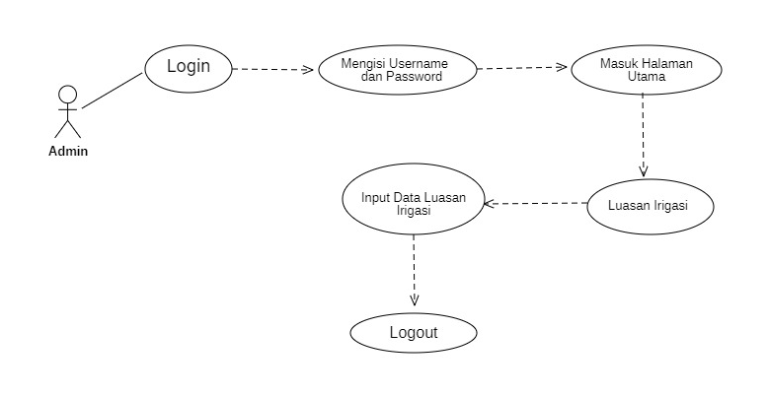
Figure 1 Use case Modeling
2. Activity Diagram
Activity Diagram is a workflow or activity in a system. In the Activity Diagram, this system explains the process in the system. Login activity diagram, describes 2 actors, namely super admin and admin. Before logging in, the user fills in the username and password to enter the system. If the username and password are wrong, it will return to the login page, and if the username and password are correct, the main page of the system will appear. More details can be seen in Figure 2.
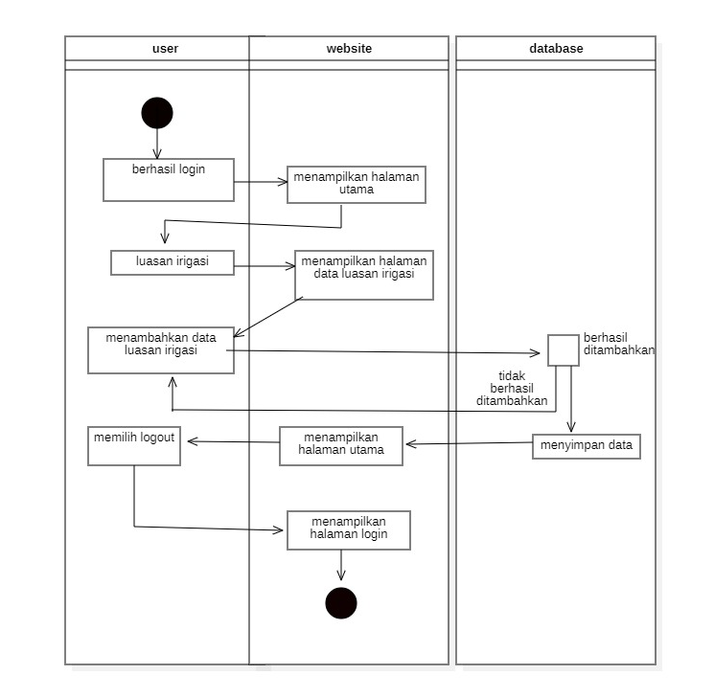
Figure 2 Activity diagram
3. Sequence Diagram
Sequence Diagram to explain the series of messages sent and interactions between projects, as can be explained by Figure 3.
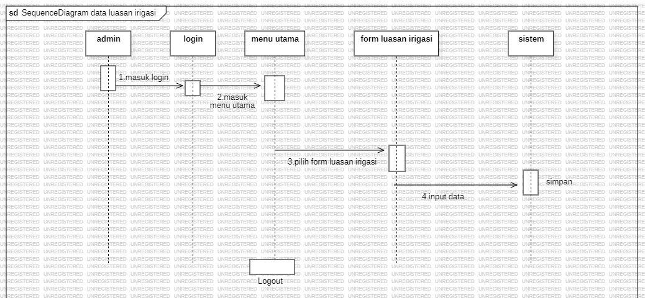
Figure 3. Sequence Diagram

4. Entity Relationship Diagram (ERD)
Entity Relationship Diagram is used to show the relationships between entities required by the system, as can be explained in Figure 4.

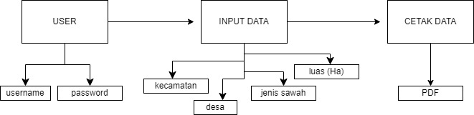
Figure 4. Entity Relationship Diagram
Results and Discussion
To create a Rice Field Irrigation Data Collection Information System at the Department of Agriculture, there are several hardware and software used, namely:

1. Hardware
The hardware used in the Rice Field Irrigation Data Collection Information System at the Department of Agriculture is one Asus X441M Laptop unit with the following specifications:

Table 1. Hardware Specification
Name | Specifications
1. Processor | Intel® celeron tipe N4020 up to 2.8 GHz
2. RAM | 4GB
3. Hardisk | 1TB
4.LCD | 14 Inci
5.Keyboard dan mouse | Standar

2. Software
The software needed to create this system is:

Table 2. Software Specifications
Name | Specification
1. Operations System | Microsoft Windows 10
2. Programing Laguange | Dart
4. Database | phpMyAdmin
5. other supporting tools | VS Code, XAMPP, Chrome

The implementation of the results of the implementation program aims to determine the flow of monitoring the addition of data so that it can be understood and can produce information that meets the objectives.

3. Main Page
This page displays a brief overview of the system being built. It also displays a summary of agricultural data for all Jombang districts using diagrams. The main page contains home, about, monitoring, agricultural data, and log-in. For more details, see Figure 5.

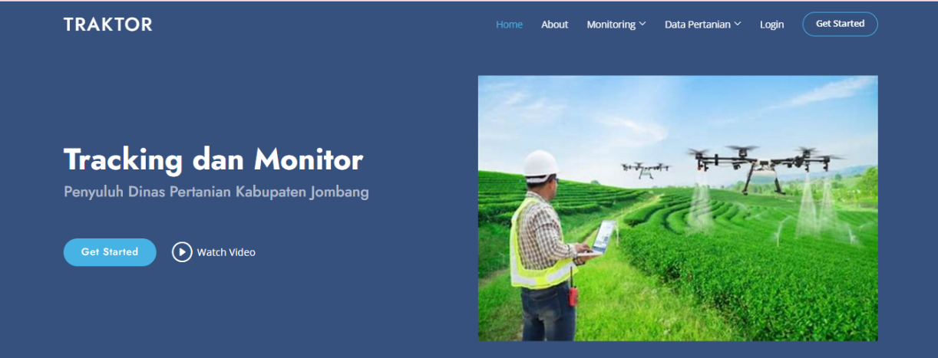
Figure 5. Main Page View
4. Login Page
Login Interface Design is the Interface Design of the Web Menu content that users can use to enter the next page according to the available flow.

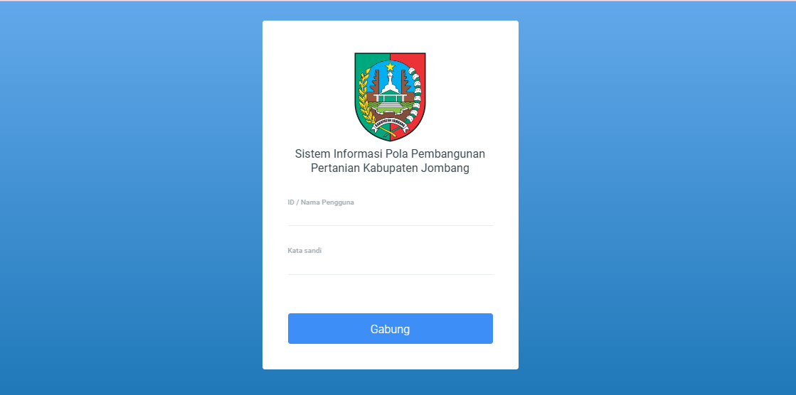
Figure 6. Login Display

In this menu, users can log in using the username and password that are already available in the database. Users can continue the menu after successfully logging in.

a. Dashboard Page
The dashboard display will appear after successful login. The dashboard page display contains a master data system, plant commodities, land distribution, nutrients, farm record dem plot, tractor, simluh, and simluhja which can be accessed for the first time when the user enters this website. This page is the first page that appears on the interface after the login page.

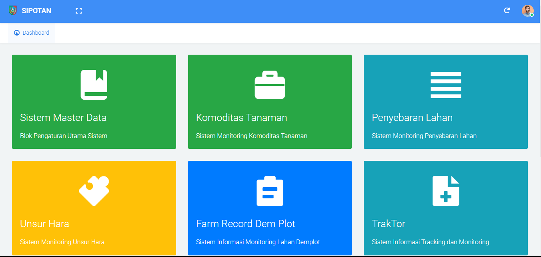
Figure 7. Dashboard Display
b. Tractor Page
The Tractor page contains the number of system blocks, the number of forms, and the number of accounts. The Tractor page display is in Figure 8.

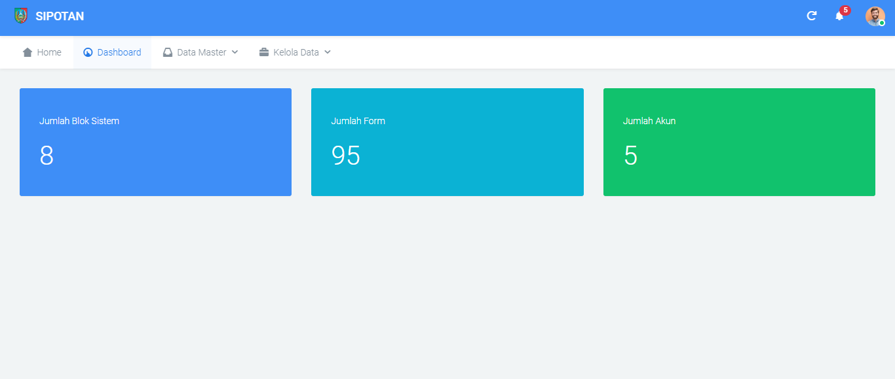
Figure 8. Traktor View
c. Data Management Display
In this menu, users can access a list of irrigation names and the amount, which can be edited, deleted, and added. Several tables include ID, District, Village, Rice Field Type, Area (Ha), Percentage (%), and options. This data management is one of the main menus on this website that can be easily accessed by users.
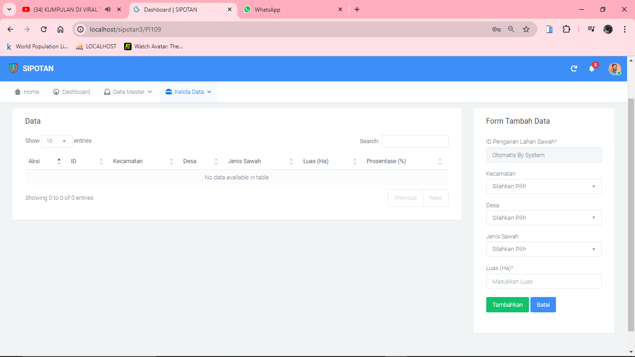
Figure 9. Data Management Display

d. Add Data Form Display
The add data form is an interface that allows users to enter new information into the system or application. This form is located to the right of the table. The display of this form is designed to be easy to use and minimize user error. The elements in it are dropdowns for sub-districts, villages, and types of rice fields as well as a text box for area (Ha) to enter the total area of ​​irrigated rice fields.

Figure 10. Add Data Form Display

e. Data Display
The incoming data display is a menu that displays any data that comes in after data input. Here, the irrigation area data that comes in will be automatically recorded after the data is input. Users can easily access this menu. Here there are tables and edits, add and delete data. This menu is dynamic according to the flow created in the design of this website.

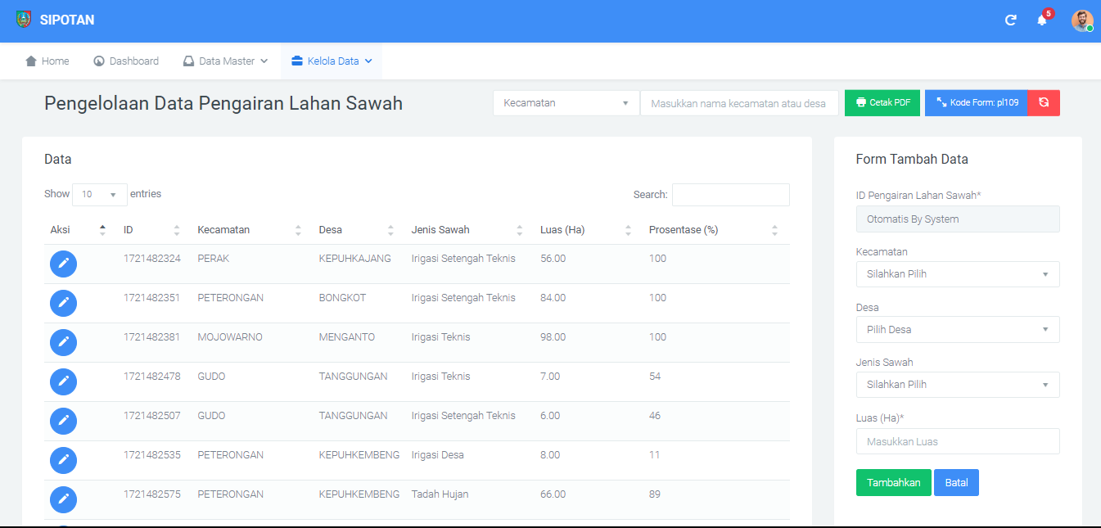
Figure 11. Data Display

f. PDF Print View
The PDF print view is the output result of the rice field irrigation area data that can be summarized according to village or sub-district. Admin can choose between the two options that have been provided in the dropdown. If you choose a sub-district, you can write the name of the sub-district next to the sub-district dropdown. This also applies to village recaps. After that, the admin can click the print PDF button next to it.

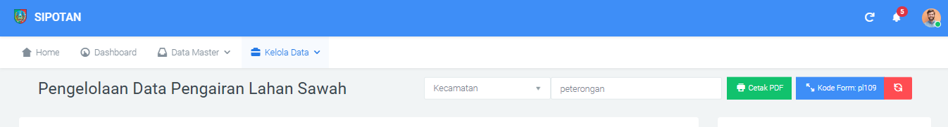
Figure 12. PDF pre-print menu display

After clicking the green print PDF button, the admin will then be directed to the following page:

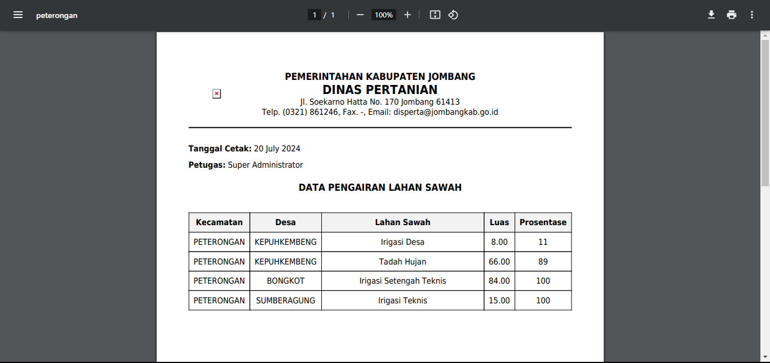
Figure 13. View of PDF Print
g. Logout
Logout is the last menu on this website. Logout can be accessed by users to exit the website and return to the login page again.

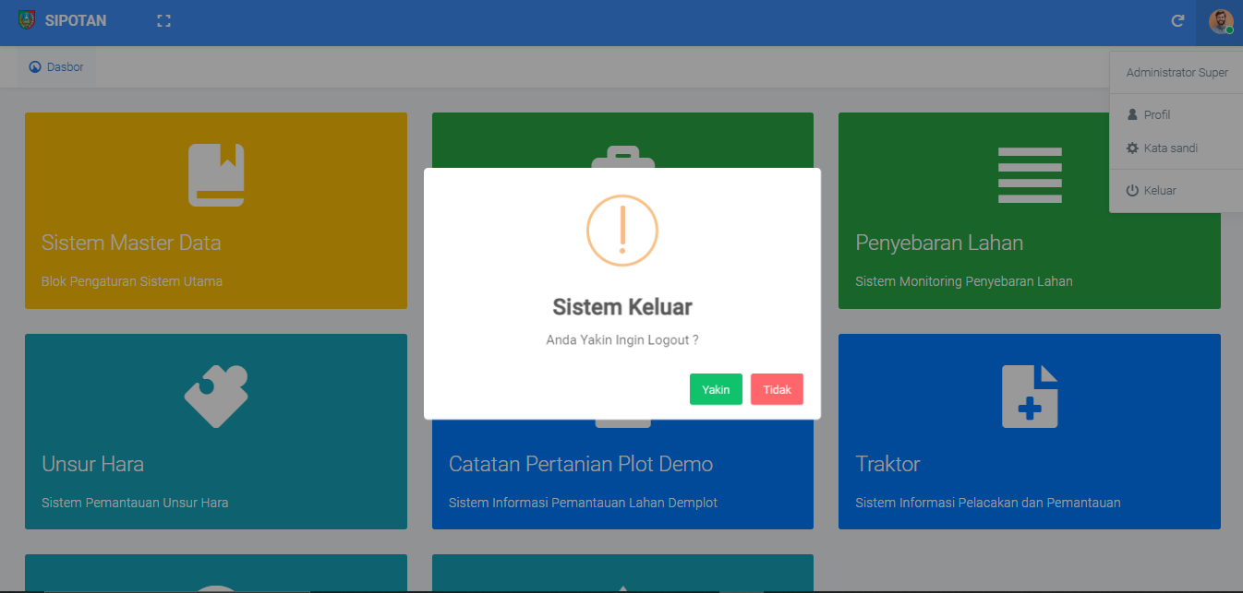
Figure 14. Logout
h. Implementation of DataBase
Database implementation based on database design done using phpMyAdmin software. The irrigation_rice_field table consists of 10 attributes, namely id, sub-district_id, village_id, rice field_type_id, area, percentage, date_created, date_updated, id_created, and id_updated. The display of the irrigation_rice_field table can be seen in Figure 15.
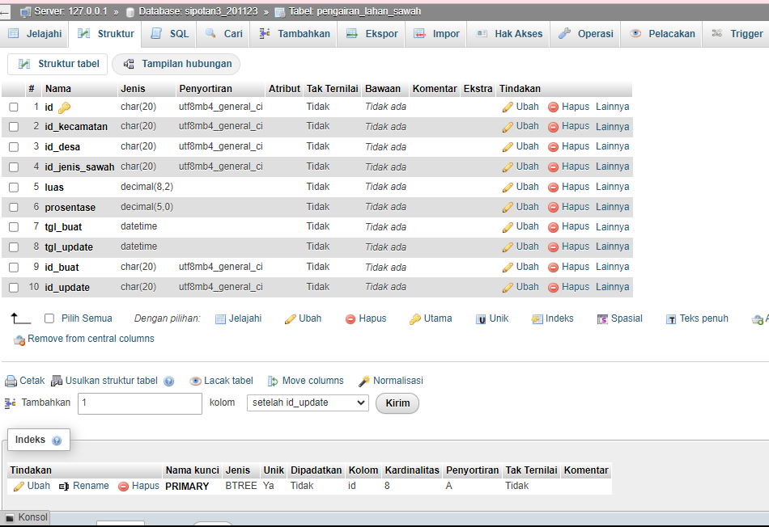
Figure 15. Implementation of Database
CONCLUSION
Based on the results of the discussion that has been done, the author can draw the following conclusions:
- The information system for recording the area of ​​rice field irrigation at the Jombang Regency Agriculture Service is a proposed system to facilitate administrator staff and extension workers in recording the area of ​​irrigation in Jombang Regency
- This system allows related government extension workers to obtain accurate and up-to-date information regarding the condition of rice field irrigation
- This system can help the Jombang Regency Agriculture Service to improve the efficiency of water use and irrigation planning.
- 4. the bookkeeping process at the Jombang Regency Agriculture Service is better because there is less loss or duplication of data and the data search process is more efficient in addition to making reports that are more time-saving and more accurate.

REFERENCES
Asenan, A., Tristianto, D., & Achlaq, M. M. (2024). Sistem Informasi Geografis Lahan Dan Irigasi Pertanian Desa Sugihwaras Menggunakan Leaflet. JATI (Jurnal Mahasiswa Teknik Informatika), 8(3), 3208-3215.
Badrul, M. (2021). Penerapan Metode Waterfall Untuk Perancangan Sistem Informasi Inventory Pada Toko Keramik Bintang Terang. PROSISKO: Jurnal Pengembangan Riset dan Observasi Sistem Komputer, 8(2), 57-52.
HARTONO, C. (2023). Studi Kinerja Jaringan Irigasi Rawa Menggunakan Aplikasi Epaksi Pada Daerah Irigasi Rawa Kumpeh (Doctoral dissertation, Universitas Batanghari Jambi)
Muthohari, A. R. (2013) Rancang bangun sistem informasi geografis jaringan irigasi berbasis web studi kasus: pusdatin kementerian pertanian ri (Bachelor's thesis, Fakultas Sains Dan Teknologi UIN Syarif Hidayatullah Jakarta).
Rahayu, U. S., Hariati, F., Alimuddin, A., & Nandiasa, J. E. (2023). Perhitungan Kebutuhan Air Irigasi untuk Perluasan Daerah Irigasi (Studi Kasus: Daerah Irigasi Cisadeng II, Desa Leuwisadeng, Kecamatan Leuwisadeng, Kabupaten Bogor). Jurnal Komposit: Jurnal Ilmu-ilmu Teknik Sipil, 7(1), 101-112.
Sari, A. K. (2019). Analisis Kebutuhan Air Irigasi Untuk Lahan Persawahan Dusun Toâ€™ Pongo Desa Awo Gading Kecamatan Lamasi. Pena Teknik: Jurnal Ilmiah Ilmu-ilmu Teknik, 4(1), 47-51
Victorinata, I. P. A., Putra, I. G. J. E., & Permana, P. T. H. (2023). Model Sistem Informasi Geografis Berbasis Web untuk Pemetaan Irigasi Sawah. Jutisi: Jurnal Ilmiah Teknik Informatika dan Sistem Informasi, 12(1).
Walid, M., Hoiriyah, H., & Fikri, A. (2022). Pengembangan Sistem Irigasi Pertanian Berbasis Internet Of Things (IoT). Jurnal Mnemonic, 5(1), 31-38.

